Name
Instructor
Course
Date
Artwork of Up to 1800s: Seal of Tarkasnawa
Introduction
The seal of Tarkasnawa is an artwork of sculpture made around the 13th to 14th Centuries among the three generations of the kings of Mira (Hawkins 2). The silver seal is found at the Walters art museum, located in the Baltimore, United States of America. Normally, the seal is commonly referred to as the Tarkondemos seal. However, according to the Walters art museum, the artists behind the making of the seal are the Hittites. It was a powerful symbol of authority among Anatolia’s kings of Mira (Guterbock 7). This paper, therefore, analyzes the importance of the seal and its meaning among Anatolia's Mira kings, its matter and content, and characteristic to time attributed to the artwork.
Reflection of the Artwork to Its Culture
The seal was an important sign of the authority of the Mira kingdom, for it fueled a crucial role in decipherment of Hittite language (Guterbock 8). The seal, which showed a drawing of an individual holding a spear in an overstretched hand with a shoulder of the other hand carrying a bow and a round cap protruding at the forehead, was a representation of the prince kings of the kingdom. Notably, it symbolizes authority by showing that the kingdom was protected by the able leadership of the king and the prince. He was expected to take over the leadership of the kingdom in case of anything. Only the kings and the princes were allowed to wear in that form, and so anybody who interacted with the seal just knew that the communication was from authorities, from the king (Feldman 43).
Figure1: Seal of Tarkasnawa

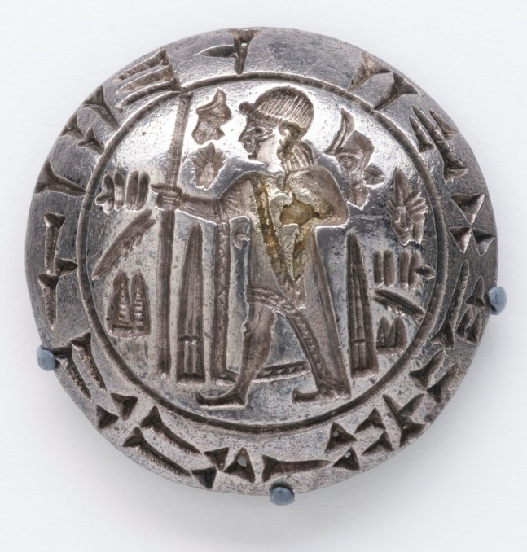
The Subject Matter and Content of the Artwork
In the seal, there is an inscription of KARABEL A, which gives the name of the father and the grandfather of king Tarkansawa with an interpretation being king of the land of Mira (Hawkins 9). The inscriptions done in Luwian hieroglyphic have a geographical implication of the Mira kingdom and point out that king Tarkansawa could be the last generation of kings in his lineage. Additionally, the seal’s inscription has been key in determining the connection between Mira and Alantalli. It archeologically fits to show that the two regions were once ruled by a common ruler, the Tarkansawa king (Hawkins 18). Generally, the artwork served the purpose of being a symbol of authority and unity in the whole kingdom because it bears the names of the three kings of Mira and shows the geographical coverage of the kingdom.
Characteristic of The Artwork to Time
According to the Walters art museum, the artwork is silvery in color, made of silver metal, 1cm high with a radius of 2.1cm. Hawkins (1) reveals that when Anatolia came into existence, the period was Bronze Age. This shows that at this particular time, the use of silver and, therefore, silvery color in the king’s seals meant a sign of wealth and respect in the kingship. Silver was the most valuable commodity at this time, and those who owned it were associated with wealth and power. Silvery color automatically creates an appealing mood for the observer. As a result, this made the subjects of the king respect and be obedient to the king's instructions upon seeing the seal. The silvery color thumped the authority of the king to his subjects through the seal.
The piece conveyed a socio-political message. Through the inscription written that Tarkasnawa, king of Mira, means that through the seal, all the members of the kingdom were made aware of who their ruler was, and so nobody was expected to deviate. Thus, the seal symbolized the authority of king Tarkasnawa.
Conclusion
Most ancient artworks connect the present and the history of various people and regions. The Tarkasnawa seal, which became a popular symbol of authority of King Tarkasnawa among the Mira people up to the late 14th Century, revealed how Mira people used to be ruled at the time that there was little or no proper documentation of the leadership of various empires. Therefore, the artwork is essential in reflecting Anatolia's Mira people to their culture during the ancient period.

Works Cited
Art.thewarters. Images. https://art.thewalters.org/images/art/large/l_ps4_571512_fnt_dd_at19_0314-1-1-tms.jpg
Feldman, Marian H. "Frescoes, exotica, and the reinvention of the Northern Levantine kingdoms during the second millennium BCE." Representations of Political Power: Case Histories from Times of Change and Dissolving Order in the Ancient Near East (2007): 39-65.
Güterbock, Hans G. "The Hittite Seals in the Walters Art Gallery." The Journal of the Walters Art Gallery 36 (1977): 7-16.
Hawkins, J. David. "Tarkasnawa King of Mira'Tarkondemos', Boǧazköy Sealings and Karabel." Anatolian Studies (1998): 1-31.

